Infos für Pressetext

Kurzbeschreibung
Marcel Krömker steht seit über 20 Jahren als Kontrabassist auf Bühnen von Festivals und Clubs in China, Südamerika und Europa.
Seine Band Bathing Birds nahm im November mit dem New Yorker Trompeter Alex Sipiagin das Album Tweet! auf. Letzteres zeichnet sich durch den Wechsel von neuen Kompositionen und Improvisationen unter dezenter Einbindung elektronischer Instrumente aus. Besonderes Element ist dabei die Verbindung des akustischen Kontrabasses mit einem Synthesizer sowie die Integration von selbst produzierten Samples.

Es folgt eine Produktionsphase mit einer Mischung von Mike Marciano im New Yorker Systems Two Studio. Eine Videoproduktion sowie das Artwork werden von Künstlerinnen übernommen, die die Alleinstellungsmerkmale der Band aufgreifen und visualisieren. Begleitend zum Album Release läuft eine Internetkampagne.
Zusammen mit dem Businesspartner Octason Records ist es das Ziel mit Presseartikeln, dem Video und dem Artwork die Basis für eine langfristige Zusammenarbeit in Europa und Südamerika zu schaffen.

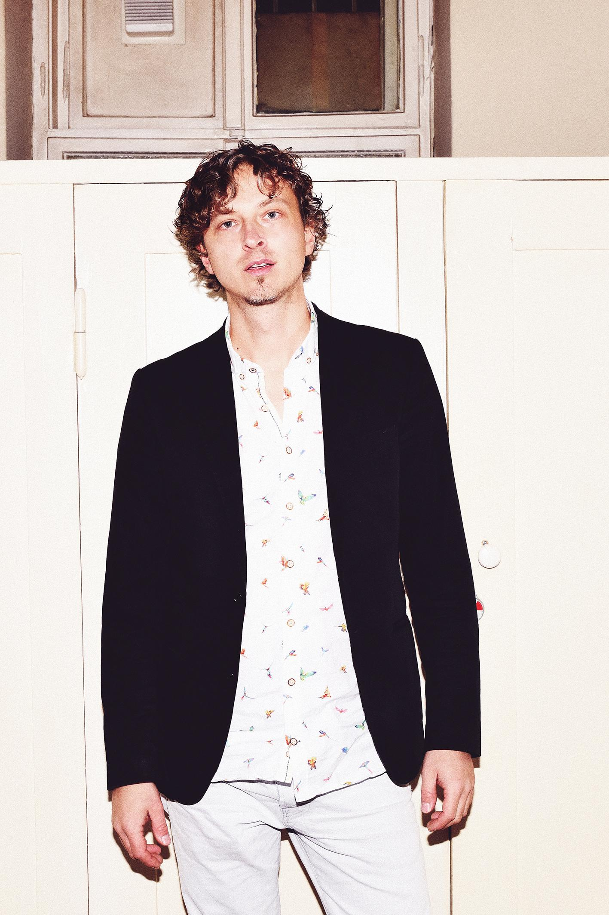

Bathing Birds - Tweet!
Marcel Krömker (- Doublebass)
Alex Sipiagin (- Trumpet)
Dan Freeman (- Saxofone)
Diego Pinera (- Drums)

Written and produced by Marcel Krömker
Mixed and Mastered by Mike Marciano at Systems Two Studio New York City
Foto and Design by Nora Blume
Recorded in Berlin at DerArt Studio by Reiner Lehmann
Recordings Supported by Berliner Senat
Marketing and release supported by Initiative Musik

www.marcelkrömker.com

Ausführliche Beschreibung aus dem Initiative Musik Antrag
Die Song Titel sind vorwiegend Zitate von südamerikanischen Schriftstellern des magischen Realismus wie Borges, Cesar Aira und Garcia Marquez. Sie zeichnen sich vor allen Dingen durch Absurditäten, Fantasie und Humor in Verbindung mit Tiefgang und Philosophie aus - ein Spiegel der musikalischen Qualitäten der Bathing Birds.
Die Titel bilden zusammen mit der außergewöhnlichen Instrumentierung und der Einwirkung der Vogelwelt auf die freien Improvisationen die Alleinstellungsmerkmale der Band. Diese Merkmale werden sowohl visuell und sollen möglichst auch textlich im gesamten Produktions- und Marketingprozess aufgegriffen und fortgeführt werden.

Das Publikum soll emotional, intellektuell und künstlerisch angesprochen werden. Durch Booklet- und Videoproduktion werden die Alleinstellungsmerkmale der Bathing Birds visuell verarbeitet und somit dem Publikum noch näher gebracht. Dabei sollen Zeichnungen, dezente Animationen und narrative Erläuterungen den Gegensatz von Synthesizer versus Kontrabass, Samples versus Schlagzeug, humorvolle Improvisation versus traditionelle Kompositionen widerspiegeln.

Die Veröffentlichung des Albums in Kombination mit einem Video dient dazu, Veranstalter anzusprechen um weitere Spielmöglichkeiten in Deutschland, Europa und Südamerika insbesondere in der Jazz- und Freien Szene zu organisieren.

Die Videoproduktion, sowie das Artwork werden von Künstlerinnen übernommen, die bereits mehrere Male erfolgreich mit Marcel Krömker zusammengearbeitet haben - sie werden für das Booklet und das Video die Alleinstellungsmerkmale der Band aufgreifen und zum Beispiel die Analogen und Digitalen Elemente in der Musik durch die Verbindung von analoger Videoaufnahme und digitaler Animation weiterführen.

Biographien

Marcel
Born in 1981 in Germany, Marcel Krömker began at the age of 6 with classical guitar lessons. The double bass training in classical and jazz music began at the age of 15. For two years he attended a workshop given by the famous American Jazz drummer Douglus Sides (played with Hank Jones, Joe Henderson, Johnny Griffin). Marcel was invited by the National Youth Orchestra and BuJazzo. He received two first prizes and several prizes at Youth Jazz Competition and a first prize at the Youth Music Competition, between 1999 and 2001. Lessons with David Friedman, as well as Masterclasses among others with Bobby McFerrin, John Rocco, Joey Baron, Kenny Werner, John Scofield, Terry Lynn Carington, Richard Bona and the bassists Drew Gress, Mike Richmond (Miles Davis), Martin Wind (Pat Metheny) and John Clayton (Count Basie) followed during his studies at the Conservatorium van Amsterdam and the Jazz Institute Berlin. He also collaborats with Visual Artitsts, Theater productions, Movie makers and dancers. Some of his musical highlights are concerts with Nils Landgreen, Toni Lakatosh, Tino Derado, Changuito (9 Grammy awards), Pernell Saturnino, Michael Moore, Jasper Blom, Leni Stern, Diego Pinera, Philip Gropper and many others. Since 2007 he works as a touring and studio musician with releases by well-known labels such as Traumton, ACT and Laika with Pär Lammers Trio, Chris Gall Trio feat. Center, Sebastian Schunke Group, Enik, Ed Kröger Quintet, Mr.EART. Marcel Krömker was performing all over the world in 24 countries of Europe, China, Korea, UAE, Africa/Marocco, Argentina, Uruguy, Peru, Columbia, Venezuela and the United States.

Alex Sipiagin
Jazz Festivals worldwide has seen Alex Sipiagin performing with the likes of Dave Holland, Michael Brecker, the Mingus groups, etc. Born on June 11, 1967 inYaroslavl, Russia, Alex began studying the trumpet at age 12, studying at the Moscow Music Institute and the Gnessin Conservatory in Moscow where hereceived his Baccalaureate. In 1990, Alex participated in the International Louis Armstrong Competition sponsored by the Thelonius Monk Institute in WashingtonD.C. winning top honors and soon after relocated to the jazz mecca of the world, New York City.
Alex soon became a favored player for various bands including the Gil Evans Orchestra, Gil Goldstein's Zebra Coast Orchestra, the George Gruntz ConcertJazz Band, drummer Bob Moses' band Mozamba, Mingus Big Band as well as the Mingus Dynasty and Mingus Orchestra, and the Dave Holland Big Band, Sextetand Octet groups.
In 2003 he recorded with Michael Brecker's Quindectet touringalso with the Michael Brecker Sextet. Alex has also worked with Eric Clapton, Dr.John, Aaron Neville, Elvis Costello, Michael Franks, Dave Sanborn, Deborah Cox, legendary producer Phil Ramone, Gonzalo Rubalcaba, etc., and many of the recordings he has been involved in has been nominated and/or won the Grammy's (Dave Holland Big Band's "What Goes Around," and "Overtime,"Michael Brecker's Qindectet "Wide Angles").
As a soloist, Sipiagin has eleven recordings out to his credit and has toured extensively throughout Europe, U.S., Japan and Russia with his own group. Healso teaches at the Groningen Prince Claus Conservatory, Academy of Music, Basel, Switzerland as well steady professorship at NYU.
Recorded 15 solo albums for one of prestiges jazz label "CrissCrossJazz"
His recent album of his compositions and arrangements "Balance 38-58" features such noted musicians as Eric Harland, David Binney, Adam Rogers and Matt Brewer.

Dan Freeman
Dan Freeman is a Tasmanian saxophonist, singer-songwriter, multi-instrumentalist composer, producer, artist and coffee roaster. He has been predominantly seen on stage as a sideman saxophonist and is the creator of the Berlin based band Dan Freeman and the Serious, which since 2007 has been creating music, most of which can be described as experimental Indie Pop. He is well known for his calm, high and warm voice and intricate songwriting style.
Freeman’s music has encompassed a number of styles over the course of his career, avant-garde Jazz, Grunge, Afro-Cuban Jazz, Indie Rock, Post New Wave, Electronic music, African tribal, Indian, new Psychedelic and Punk Pop. Though his popularity has been somewhat slow moving within the Popular scene over the years, much of Freeman’s songs have made a significant impact within the underground Berlin Indie and Jazz scenes. His music can be compared to artists such as Radiohead, Talking heads, Paul McCartney and the Wings, Beck, Grizzly Bear, George Michael, David Bowie. On the saxophone he is highly inspired by the great saxophone players of the 4Os, 50s and 60s.

Diego Piñera
Diego Pinera was born 1981 in Montevideo, Uruguay, but has lived in Germany since 2003. He studied at the Berklee College of Music (U.S.), the University of Music in Havana (Cuba), and the University of Music and Theater in Leipzig (Germany). Pinera’s encounters with Latin American music, and with jazz in all its breadth, have led him to develop an unmistakable style. Through the combination of his advanced conception of rhythm, a jazz sound with a Latin touch, and the freedom of improvisation his strong character comes across vividly. In Pineras music there is musical complexity and virtuosity in abundance, but it is imbued with great subtlety.Diego Pinera was also the winner from the german award ECHO for best jazzdrummer in 2017.

